1) 1) Write a program that finds whether the given number N is Prime or not.

If the number is prime, the program should return 2 else it must return 1.

Assumption: 2 <= N <=5000, where N is the given number.

Example1: if the given number N is 7, the method must return 2

Example2: if the given number N is 10, the method must return 1

PROGRAM:

a= int(input())

if a % 2 == 1:

print("2")

else:

print("1")

OUTPUT:

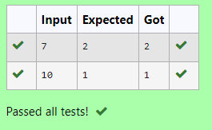

2) Write a program to find the count of unique digits in a given number N. The number will be passed to the program as an input of type int.

Assumption: The input number will be a positive integer number >= 1 and <= 25000.

For e.g.

If the given number is 292, the program should return 2 because there are only 2 unique digits '2' and '9' in this number

If the given number is 1015, the program should return 3 because there are 3 unique digits in this number, '1', '0', and '5'.

PROGRAM:

print(len(set(input())))

OUTPUT:

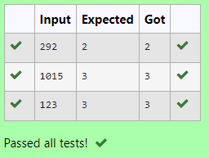

3) Given a number N, find the next perfect square greater than N.

Input Format:

Integer input from stdin.

Output Format:

Perfect square greater than N.

Example Input:

10

Output:

16

PROGRAM:

import math as m

a = int(input())

for i in range(a, 10000):

X = m.sqrt(i)

if(i % x == 0):

print(i)

break

OUTPUT:

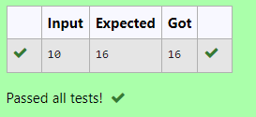

4) Write a program to find the count of non-repeated digits in a given number N. The number will be passed to the program as an input of type int.

Assumption: The input number will be a positive integer number >= 1 and <= 25000.

Some examples are as below.

If the given number is 292, the program should return 1 because there is only 1 non-­repeated digit '9' in this number

If the given number is 1015, the program should return 2 because there are 2 non-repeated digits in this number, '0', and '5'.

If the given number is 108, the program should return 3 because there are 3 non-­repeated digits in this number, '1', '0', and '8'.

If the given number is 22, the function should return 0 because there are NO non-­repeated digits in this number.

PROGRAM:

n = (input())

l=[0] \*10

for i in n:

l[int(i)]+=1

c=0

for i in l:

if i==1:

c += 1

print(c)

OUTPUT:

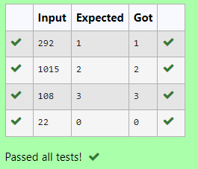

5) Write a program to find the sum of the series 1 +11 + 111 + 1111 + . . . + n terms (n will be given as input from the user and sum will be the output)

Sample Test Cases

Test Case 1

Input

4

Output

1234

Test Case 2

Input

6

Output

123456

PROGRAM:

a=int(input())

n=0

t=0

for i in range (a):

n=n\*10+1

t+=n

print(t)

OUTPUT:

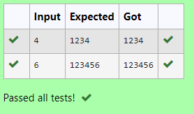

6) Given an integer N, check whether N the given number can be made a perfect square after adding 1 to it.

Input Format:

Single integer input.

Output Format:

Yes or No.

Example Input:

24

Output:

Yes

Example Input:

26

Output:

No

PROGRAM:

Import math as b

a=int(input())

a=a+1

m=b.sqrt(a)

if m %2==0 or m%2==1:

print(“Yes”)

else:

print(“No”)

OUTPUT:

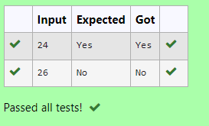

7) Determine the factors of a number (i.e., all positive integer values that evenly divide into a number).

PROGRAM:

a=int(input())

for i in range (1,a+1):

if (a%i==0):  
 print(I,end=” “)

OUTPUT:

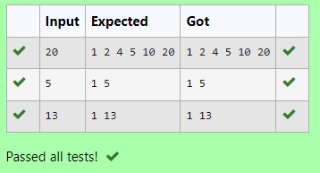

8) Write a program to return the nth number in the fibonacci series.

The value of N will be passed to the program as input.

NOTE: Fibonacci series looks like –

0, 1, 1, 2, 3, 5, 8, 13, 21, 34, 55, . . . and so on.

i.e. Fibonacci series starts with 0 and 1, and continues generating the next number as the sum of the previous two numbers.

• first Fibonacci number is 0,

• second Fibonacci number is 1,

• third Fibonacci number is 1,

• fourth Fibonacci number is 2,

• fifth Fibonacci number is 3,

• sixth Fibonacci number is 5,

• seventh Fibonacci number is 8, and so on.

PROGRAM:

z=int(input())

a=0

b=0

c=0

for i in range (0,z-1):

a=b

b=c

c=a+b

print(c)

OUTPUT:

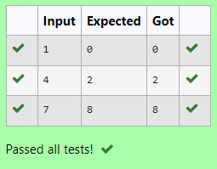

9) Given a positive integer N, check whether it can be represented as a product of single digit numbers.

Input Format:

Single Integer input.

Output Format:

Output displays Yes if condition satisfies else prints No.

Example Input:

14

Output:

Yes

Example Input:

13

Output:

No

PROGRAM:

a=int(input())

if a%2==0 or %3==0 or a%5==0 ora%6==0:

print(“Yes”)

else:

print(“No”)

OUTPUT:

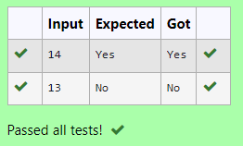

10) A Number is said to be Disarium number when the sum of its digit raised to the power of their respective positions becomes equal to the number itself. Write a program to print number is Disarium or not.

Input Format:

Single Integer Input from stdin.

Output Format:

Yes or No.

Example Input:

175

Output:

Yes

Explanation

1^1 + 7^2 +5^3 = 175

Example Input:

123

Output:

No

PROGRAM:

a=int(input())

x=str(a)

count=0

for i in range (len(x)):

tot=pow(int(x[i]),i=1)

count +=a:

if count ==a:

print(“Yes”)

else:

print(“No”)

OUTPUT:

